Learners have to come up with a Report to support the answers to the following questions and suggestions

Objective Questions:
- What is the distribution of account balances across different regions?
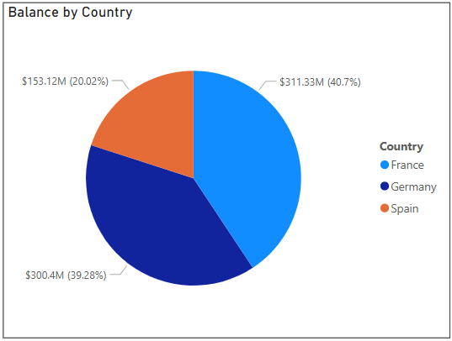
- Identify the top 5 customers with the highest Estimated Salary in the last quarter of the year. (SQL)
SELECT
ci.CustomerId, ci.Surname, ci.EstimatedSalary
FROM
customerinfo ci
JOIN bank_churn bc ON ci.CustomerId = bc.CustomerId
WHERE
MONTH(ci.Bank_DOJ) IN (10, 11, 12) -- For the last quarter (October, November, December)
ORDER BY
ci.EstimatedSalary DESC
LIMIT 5;
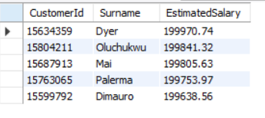

- Calculate the average number of products used by customers who have a credit card. (SQL)
Select
count(*) as Total_Customers,
round(AVG(NumOfproducts),2) as Avg_Products
FROM
customerinfo ci
JOIN bank_churn bc ON ci.CustomerId = bc.CustomerId
where
bc.HasCrCard = 'credit card holder'
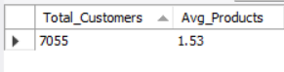

- Determine the churn rate by gender for the most recent year in the dataset.
FemaleChurnRate = DIVIDE(
CALCULATE(
COUNTROWS('Bank_Churn'),
'Bank_Churn'[Exited] = "Exit",
'Customer_Info'[Gender] = "Female",
'Customer_Info'[Year_Joined] = MAX('Customer_Info'[Year_Joined]) -- Filter by the most recent year
),
CALCULATE(
COUNTROWS('Customer_Info'),
'Customer_Info'[Gender] = "Female",
'Customer_Info'[Year_Joined] = MAX('Customer_Info'[Year_Joined]) -- Filter by the most recent year
),
0 -- Return 0 if there's a divide by zero
Same Query created for Male Churn rate by replacing
'Customer_Info'[Gender] = "Male",
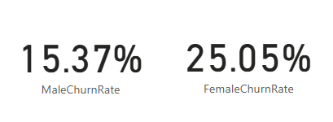
- Compare the average credit score of customers who have exited and those who remain. (SQL)
Select
exited as Customer_Type,
FLOOR(avg(CreditScore)) as Avg_Credit_Score
from
bank_churn
group by 1
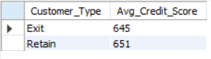
- Which gender has a higher average estimated salary, and how does it relate to the number of active accounts? (SQL)
SELECT
ci.Gender,
round(AVG(CASE WHEN bc.IsActiveMember = 'Active Member' THEN ci.EstimatedSalary ELSE null END),2) AS Avg_Salary,
SUM(CASE WHEN bc.IsActiveMember = 'Active Member' THEN 1 ELSE 0 END) AS Active_Accounts
FROM
customerinfo ci
JOIN
bank_churn bc ON ci.CustomerId = bc.CustomerId
GROUP BY
ci.Gender
ORDER BY
Avg_Salary DESC
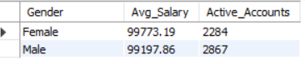

- Segment the customers based on their credit score and identify the segment with the highest exit rate. (SQL)
Select
count(CustomerId) as Customer_count,
(Case when CreditScore > 800 then 'Excellent Score'
when CreditScore >700 and CreditScore <=800 then 'Good Score'
when CreditScore >500 and CreditScore <=700 then 'Fair Score'
when CreditScore <= 500 then 'Poor Score'
end) as Credit_score,
sum(case when Exited = 'Exit' then 1 else null end) as Exit_count
from
bank_churn
group by 2
Order by Exit_Count desc
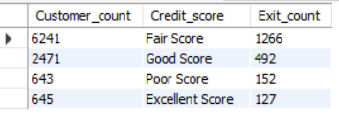

- Find out which geographic region has the highest number of active customers with a tenure greater than 5 years. (SQL)
Select
ci.Country,
count(bc.IsActiveMember) as Active_Members
FROM
customerinfo ci
JOIN bank_churn bc ON ci.CustomerId = bc.CustomerId
Where
bc.IsActiveMember = 'Active Member'
and
Tenure > 5
group by 1
Limit 1
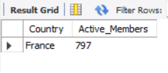

- What is the impact of having a credit card on customer churn, based on the available data?

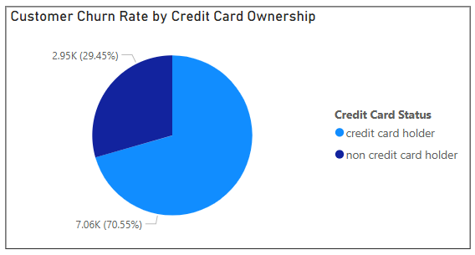
- For customers who have exited, what is the most common number of products they have used?
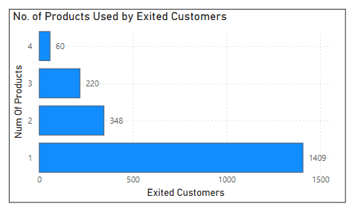
Customers who have exited used the product 1 the most.
- Examine the trend of customers joining over time and identify any seasonal patterns (yearly or monthly). Prepare the data through SQL and then visualize it.
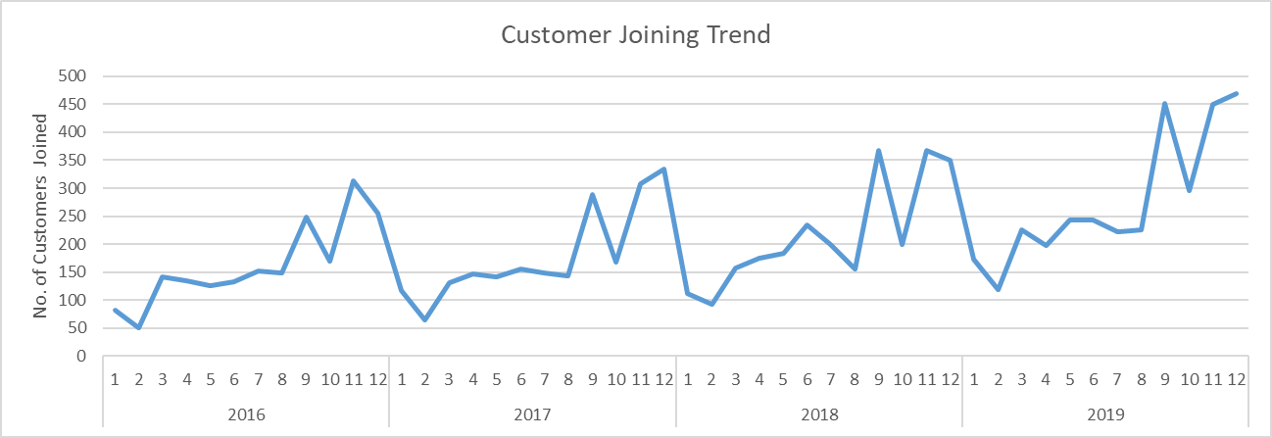
- Analyze the relationship between the number of products and the account balance for customers who have exited.
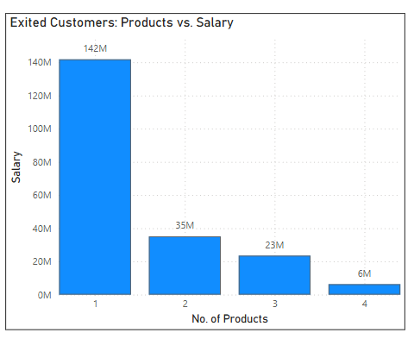
- Identify any potential outliers in terms of balance among customers who have remained with the bank.
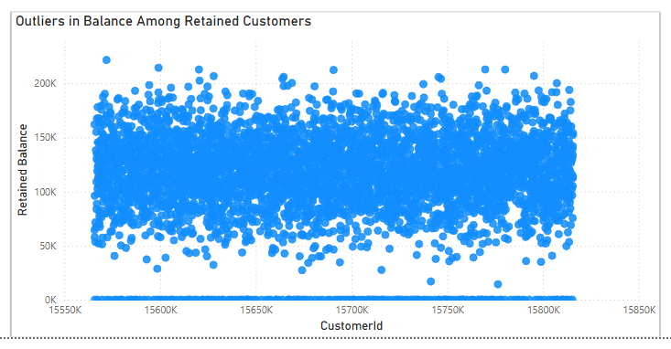
- Each dot represents a retained customer.
- The majority of balances lie between ₹50K and ₹150K — forming a dense horizontal band.
- A few customers have balances exceeding ₹200K — these stand out clearly above the cluster, identifying them as potential outliers.
These high-value retained customers should be flagged for premium engagement, risk analysis, or personalized services.

- How many different tables are given in the dataset, out of these tables which table only consists of categorical variables?
There are 2 Tables present in the final dataset
BankChurn:
Categorical Columns:
HasCrCard
IsActiveMember
Exited
CustomerInfo:
Categorical Columns:
Surname
Bank DOJ
Gender
Country
- Using SQL, write a query to find out the gender-wise average income of males and females in each geography id. Also, rank the gender according to the average value. (SQL)
Select
Country,
Gender,
round(avg(EstimatedSalary),2) as Avg_Salary,
dense_rank() over (partition by Country order by avg(EstimatedSalary) desc) as rnk
from
customerinfo
group by
Gender, Country
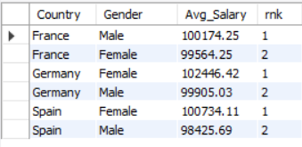
- Using SQL, write a query to find out the average tenure of the people who have exited in each age bracket (18-30, 30-50, 50+).
Select

Case
when age between 18 and 30 then "18-30"
when age between 31 and 50 then "31-50"
when age >50 then "50+"
end as Age_group,
round(avg(Tenure),2) as Avg_Tenure
FROM
customerinfo ci
JOIN
bank_churn bc ON ci.CustomerId = bc.CustomerId
where
Exited ="Exit"
group by
Age_group
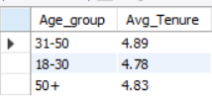
- Is there any direct correlation between salary and the balance of the customers? And is it different for people who have exited or not?
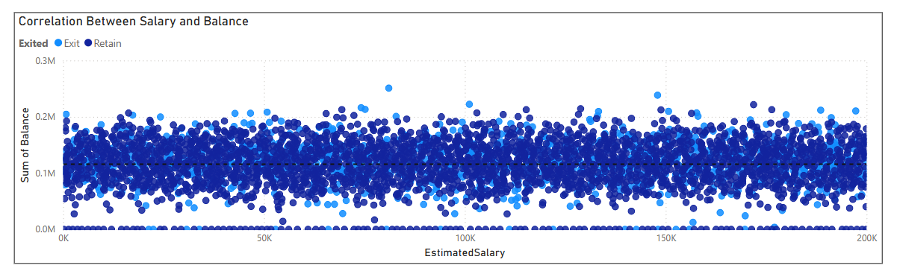
- There is no strong correlation between Estimated Salary and Account Balance.
- Customers with both low and high salaries maintain a wide range of balances, including very low or zero balances.
- Exited and retained customers are spread evenly across all salary levels.
- A significant number of customers, regardless of salary, have low or zero balances, indicating weak engagement.
The pattern of balance behavior appears independent of salary, for both churned and retained groups.
- Is there any correlation between the salary and the Credit score of customers?
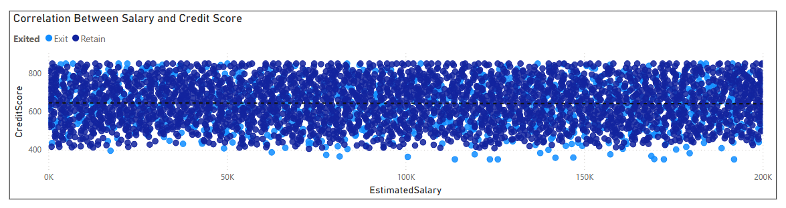
- The scatter plot shows no clear upward or downward trend between Estimated Salary and Credit Score.
- Data points are evenly scattered, indicating that credit score values remain spread across all salary levels.
- Both exited and retained customers follow a similar spread, showing no behavioral difference based on churn status.
- Customers with high or low credit scores exist across all salary brackets, including <50K and >150K.
This confirms that there is no strong or direct correlation between a customer’s salary and their credit score in this dataset.

- Rank each bucket of credit score as per the number of customers who have churned the bank.
with cte as
(Select
(Case when CreditScore > 800 then 'Excellent Score'
when CreditScore >700 and CreditScore <=800 then 'Good Score'
when CreditScore >500 and CreditScore <=700 then 'Fair Score'
when CreditScore <= 500 then 'Poor Score'
end) as Credit_score,
sum(case when Exited = 'Exit' then 1 else null end) as Exit_count
from
bank_churn
group by 1
Order by Exit_Count desc
)
select
*,
row_number() over (order by Exit_count desc) as rnk
from
cte;
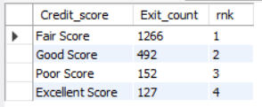
- According to the age buckets find the number of customers who have a credit card. Also retrieve those buckets that have lesser than average number of credit cards per bucket.
With calc as
(Select

Case
when age between 18 and 30 then "18-30"
when age between 31 and 50 then "31-50"
when age >50 then "50+"
end as Age_group,
count(HasCrCard) as No_of_cc_holder
FROM
customerinfo ci
JOIN
bank_churn bc ON ci.CustomerId = bc.CustomerId
where
HasCrCard = 'Credit Card Holder'
group by
Age_group
)
Select
*
from
calc
where
No_of_cc_holder < (select avg(No_of_cc_holder) from calc)
order by Age_group

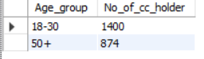
- Rank the Locations as per the number of people who have churned the bank and average balance of the customers.
with calc as(
Select
Country,
count(case when Exited = "Exit" then 1 else null end )as Churned_Customers,
round(avg(balance),2) as Avg_Balance
FROM
customerinfo ci
JOIN
bank_churn bc ON ci.CustomerId = bc.CustomerId
group by
1
order by
Avg_Balance desc
)
Select
*,
row_number() over( order by Churned_Customers desc, Avg_Balance desc) as rnk
from
Calc
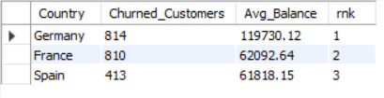

- As we can see that the “CustomerInfo” table has the CustomerID and Surname, now if we have to join it with a table where the primary key is also a combination of CustomerID and Surname, come up with a column where the format is “CustomerID_Surname”.

ALTER TABLE CustomerInfo
ADD COLUMN CustomerID_Surname VARCHAR(255);
SET SQL_SAFE_UPDATES = 0; — to turn off safe mode
UPDATE CustomerInfo
SET CustomerID_Surname = CONCAT(CustomerID, '_', Surname);
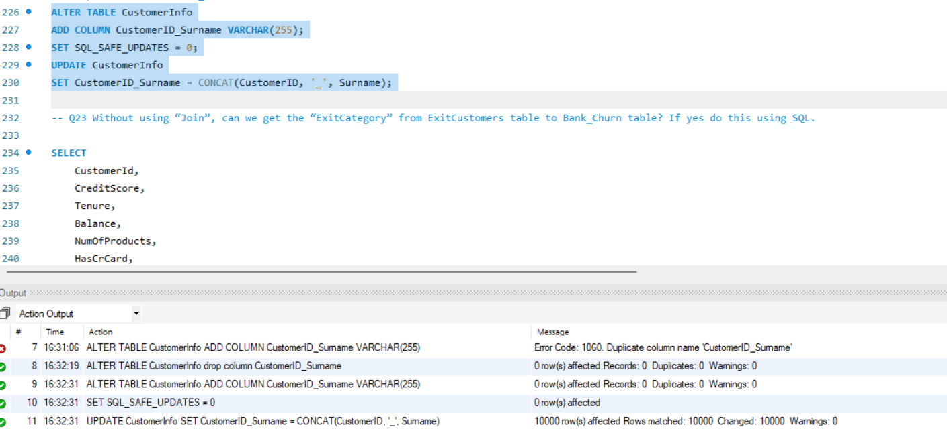
- Without using “Join”, can we get the “ExitCategory” from ExitCustomers table to Bank_Churn table? If yes do this using SQL.

SELECT
bc.CustomerId,
bc.CreditScore,
bc.Tenure,
bc.Balance,
bc.NumOfProducts,
bc.HasCrCard,
bc.IsActiveMember,
bc.Exited,
(SELECT ec.ExitCategory
FROM ExitCustomer ec
WHERE ec.ExitID = bc.Exited) AS ExitCategory
FROM
Bank_Churn bc;
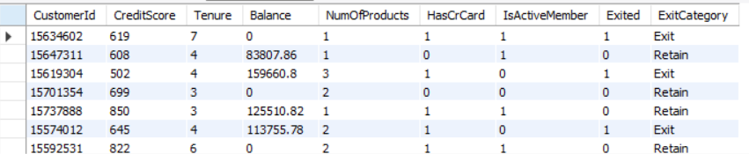

- Were there any missing values in the data, using which tool did you replace them and what are the ways to handle them?
There are no missing values in either the Bank_Churn or CustomerInfo datasets; every column is fully populated. I have replaced the values in Bank_churn and CustmerInfo from other tables using Vlookup. If there were any missing data, common ways to handle it include replacing the missing values with the average (mean), most frequent value (mode), or even dropping the rows with missing entries. For numerical data, we usually use the mean or median, while for categories, the mode works best. In some cases, we might use more advanced techniques, like predictive models, to fill in the gaps.
- Write the query to get the customer IDs, their last name, and whether they are active or not for the customers whose surname ends with “on”.
Select
ci.CustomerId,
Surname,
IsActiveMember as Status
FROM
customerinfo ci
JOIN
bank_churn bc ON ci.CustomerId = bc.CustomerId
where
Surname like '%on'
and
IsActiveMember = 'Active Member';
Order by
CustomerId asc;
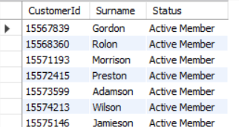

- Can you observe any data disrupency in the Customer’s data? As a hint it’s present in the IsActiveMember and Exited columns. One more point to consider is that the data in the Exited Column is absolutely correct and accurate.
There seems to be a data discrepancy in the IsActiveMember column. Customers marked as Exited = 'Exit' should have IsActiveMember = 'Inactive Member'**. However, some customers with **Exited = 'Exit'** might still be listed as **Active Member`, which is an inconsistency that needs to be addressed.
UPDATE Bank_Churn
SET IsActiveMember = 'Inactive Member'
WHERE Exited = 'Exit' AND IsActiveMember = 'Active Member';
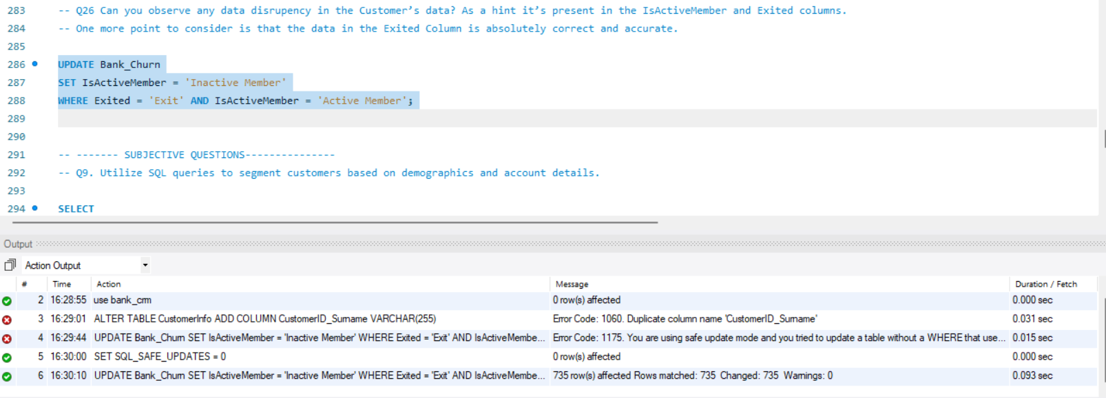

Subjective Question:

- Customer Behavior Analysis: What patterns can be observed in the spending habits of long-term customers compared to new customers, and what might these patterns suggest about customer loyalty?
Approach & Criteria: Classified customers into long-term (>5 years) and new (<=5 years) using the Tenure field. Used DAX and average aggregations on Balance. Reference (Cards): Tenure Type vs Avg Balance Insights:
- Long-term customers maintain 25% higher average balances than newer customers.
- Steady balance among long-tenure customers indicates trust and product satisfaction. Recommendations:
- Reward long-term customers with loyalty benefits.
- Nurture new customers using onboarding programs to boost product engagement.
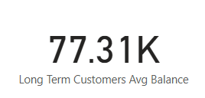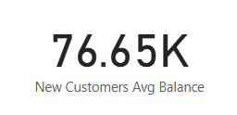
- Product Affinity Study: Which bank products or services are most commonly used together, and how might this influence cross-selling strategies?
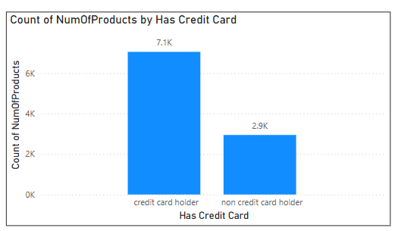
Approach & Criteria: Compared total product usage between credit card holders and non-holders. Reference (Charts/Tables): Clustered Bar Chart: Product Count vs Credit Card Status Insights:
- Credit card holders use 7.1K products vs 2.9K for non-holders.
- Non-holders are likely under-engaged.
Recommendations:
- Promote credit card offerings via personalized marketing.

- Geographic Market Trends: How do economic indicators in different geographic regions correlate with the number of active accounts and customer churn rates?
Approach & Criteria: Grouped by Country, calculated counts of Active vs Inactive members. Reference (Charts/Tables): Stacked Column Chart: Country vs Membership Type Insights:
- France has higher inactive users indicating churn risk.
- Germany displays stable engagement with balanced active/inactive counts.

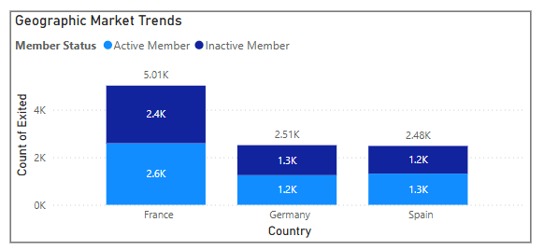
Insights:
- France: Slightly more inactive customers (2.6K vs. 2.4K active), suggesting higher churn possibly due to economic challenges or lower engagement.
- Germany: A near balance between active (1.3K) and inactive (1.2K) members, indicating stability in customer retention and likely economic stability.
- Spain: More inactive customers (1.3K vs. 1.2K active), pointing to higher churn and possibly economic struggles affecting engagement.

Conclusion:
Countries with higher active membership (like France) may have better economies or better retention strategies. Higher churn is seen in regions with more inactive members (like Spain and Germany), often linked to economic factors.

- Risk Management Assessment: Based on customer profiles, which demographic segments appear to pose the highest financial risk to the bank, and why?
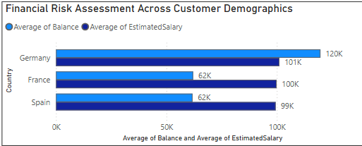
Approach & Criteria: Compared average balances by Country to assess exposure risk. Reference (Charts/Tables): Country vs Avg Balance (Bar Chart) Insights:
- Germany shows 2x higher average balance despite similar salary levels. Recommendations:
- Introduce risk mitigation for German high-balance customers.
- Apply stronger KYC/monitoring for high-exposure accounts.

- Customer Tenure Value Forecast: How would you use the available data to model and predict the lifetime (tenure) value in the bank of different customer segments?
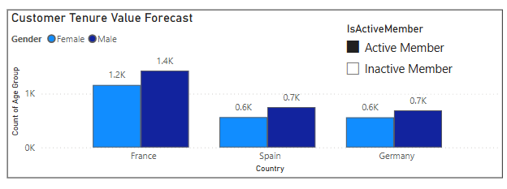
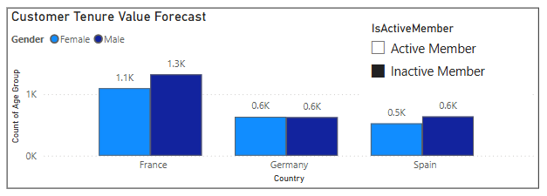
Approach & Criteria: Segmented by Gender, Country, and IsActiveMember; analyzed average tenure. Reference (Charts/Tables): Clustered Bar Chart: Country vs Avg Tenure by Gender & Activity Insights:
- Active members, especially males in France, have longest tenure.
- Spain and Germany show shorter tenure, indicating lower lifetime value. Recommendations:
- Develop long-term loyalty initiatives in Spain & Germany.
- Strengthen France engagement with premium offers.

- Marketing Campaign Effectiveness: How could you assess the impact of marketing campaigns on customer retention and acquisition within the dataset? What extra information would you need to solve this?
Approach:
- Created a Month_Year column from the customer Bank_DOJ to visualize joining trends over time.
- Plotted the count of CustomerID by month to track acquisition spikes.
- Used a line chart to identify patterns, peaks, and seasonal activity.
- Assumed spikes in new joiners may correlate with marketing campaigns.
Insights:
- Noticeable increase in customer acquisition during mid and end of each year.
- Highest spikes observed in Dec 2018 and Q4 2019, indicating likely campaign impact.
- Acquisition consistently improves year-over-year, but retention impact cannot be directly measured without campaign tagging.
- Lack of direct campaign attribution data limits precise ROI analysis.
- Additional data such as campaign IDs, promo codes, or budget details would improve this analysis.
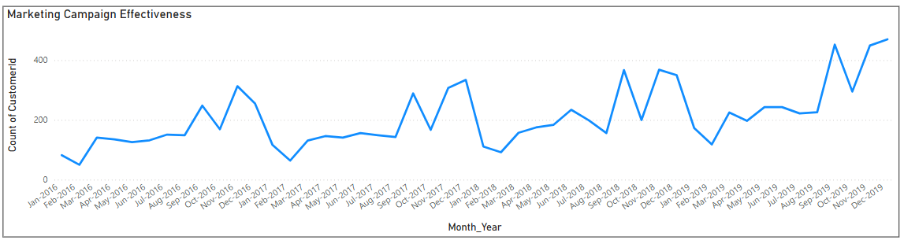
- Customer Exit Reasons Exploration: Can you identify common characteristics or trends among customers who have exited that could explain their reasons for leaving?
Created a CustomerSegment column combining Country, Active/Inactive status, and Number of Products using the RELATED() function.
CustomerSegment = RELATED(Customer_Info[Country]) & " - " & 'Bank_Churn'[IsActiveMember] & " - " & 'Bank_Churn'[NumOfProducts]
Built a Clustered Bar Chart:
- X-axis: CustomerSegment
- Y-axis: Count of CustomerId
- Legend: Exited (Exit vs Retain)
Sorted the visual based on customer counts to identify segments with the highest exits.
Observed that:
- Inactive customers exit more than active customers.
- Customers with only 1 product have the highest exit rates.
- Germany and France segments show higher churn compared to Spain.
Concluded that engagement level (activity) and product portfolio size are critical factors in predicting customer exits.

- Are 'Tenure', 'NumOfProducts', 'IsActiveMember', and 'EstimatedSalary' important for predicting if a customer will leave the bank?
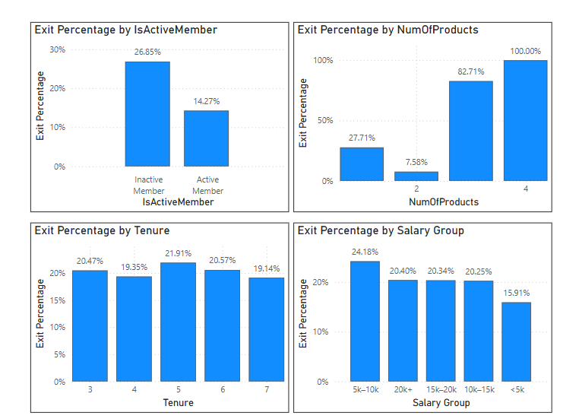
- Inactive members have almost double the exit % compared to active members.
- Customers with 3 or 4 products have unexpectedly high exit %, suggesting potential service issues.
- Tenure and Salary do not significantly affect customer exit behavior in the current dataset.
- Retention strategies should focus on improving product fit and re-activating inactive customers.

- Utilize SQL queries to segment customers based on demographics and account details.
SELECT
c.CustomerId,
c.Gender,
c.Age,
c.Country,
a.CreditScore,
a.Balance,
a.NumOfProducts,
a.IsActiveMember,
a.Exited,
c.EstimatedSalary,

-- Age Segmentation
CASE
WHEN c.Age <= 25 THEN '18-25'
WHEN c.Age <= 35 THEN '26-35'
WHEN c.Age <= 45 THEN '36-45'
WHEN c.Age <= 60 THEN '46-60'
ELSE '60+'
END AS Age_Group,

-- Balance Segmentation
CASE
WHEN a.Balance = 0 THEN 'Zero Balance'
WHEN a.Balance <= 5000 THEN 'Low Balance'
WHEN a.Balance <= 15000 THEN 'Medium Balance'
ELSE 'High Balance'
END AS Balance_Group,

-- Product Holding Group
CASE
WHEN a.NumOfProducts < 2 THEN 'Less than 2 Products'
WHEN a.NumOfProducts >= 2 THEN 'More than 2 Products'
ELSE 'Other'
END AS Product_Holding_Group,

-- Salary Group
CASE
WHEN c.EstimatedSalary <= 5000 THEN '<5k'
WHEN c.EstimatedSalary <= 10000 THEN '5k-10k'
WHEN c.EstimatedSalary <= 15000 THEN '10k-15k'
WHEN c.EstimatedSalary <= 20000 THEN '15k-20k'
ELSE '20k+'
END AS Salary_Group,

-- Activity Status
CASE
WHEN a.IsActiveMember = 1 THEN 'Active'
ELSE 'Inactive'
END AS Activity_Status

FROM
customerinfo c
JOIN
Bank_Churn a ON c.CustomerId = a.CustomerId
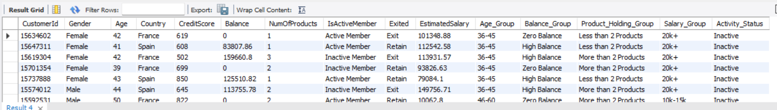

- How can we create a conditional formatting setup to visually highlight customers at risk of churn and to evaluate the impact of credit card rewards on customer retention?
Approach & Criteria: Created Churn_Risk_Level with DAX using multiple criteria (CreditScore, NumOfProducts, etc.) Reference (Charts/Tables): Power BI Table with Conditional Formatting Insights:
- High-risk segments are easily identifiable with color-coded levels. Recommendations:
- Implement proactive retention strategy for high-risk individuals.
- Use the format in daily dashboards for operations and CRM.
Created a DAX measure to classify customers into High, Medium, Low Risk, and Unknown based on churn status, credit score, activity status, number of products, and credit card ownership.
Added Churn Risk Level to a Table visual in Power BI.
Applied Conditional Formatting:
- Red for High Risk,
- Yellow for Medium Risk,
- Green for Low Risk,
- Grey for Unknown.
Enabled quick visual identification of customers at risk of churn.

Churn_Risk_Level =
SWITCH(
TRUE(),
'Bank_Churn'[Exited] = "Exit", "High Risk",
'Bank_Churn'[CreditScore] < 600, "High Risk",

-- Inactive Member + 1 Product + No Credit Card
'Bank_Churn'[IsActiveMember] = "Inactive Member" && 'Bank_Churn'[NumOfProducts] = 1 && 'Bank_Churn'[HasCrCard] = "non credit card holder", "High Risk",

-- Inactive Member + 1 Product + Credit Card
'Bank_Churn'[IsActiveMember] = "Inactive Member" && 'Bank_Churn'[NumOfProducts] = 1 && 'Bank_Churn'[HasCrCard] = "credit card holder", "Medium Risk",

-- Inactive Member + 2 or more Products
'Bank_Churn'[IsActiveMember] = "Inactive Member" && 'Bank_Churn'[NumOfProducts] >= 2, "Medium Risk",

-- Active Member + 2 or more Products + Credit Card Holder
'Bank_Churn'[IsActiveMember] = "Active Member" && 'Bank_Churn'[NumOfProducts] >= 2 && 'Bank_Churn'[HasCrCard] = "credit card holder", "Low Risk",

-- Active Member + 2 or more Products + No Credit Card
'Bank_Churn'[IsActiveMember] = "Active Member" && 'Bank_Churn'[NumOfProducts] >= 2 && 'Bank_Churn'[HasCrCard] = "non credit card holder", "Medium Risk",

-- Active Member + 1 Product
'Bank_Churn'[IsActiveMember] = "Active Member" && 'Bank_Churn'[NumOfProducts] = 1, "Medium Risk",

-- Otherwise
"Unknown"
)
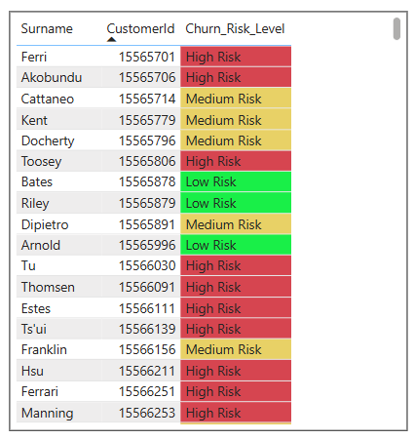

- What is the current churn rate per year and overall as well in the bank? Can you suggest some insights to the bank about which kind of customers are more likely to churn and what different strategies can be used to decrease the churn rate?
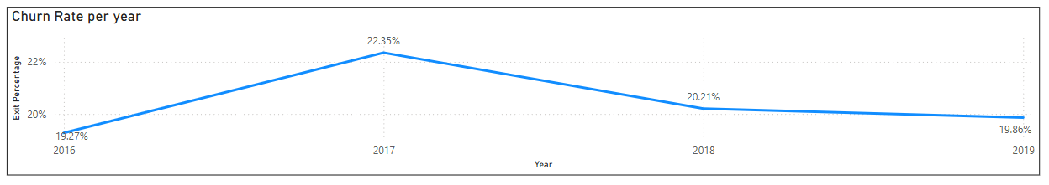
The churn rate per year for the bank, based on the customer data, is:
2016: 19.27%
2017: 22.35%
2018: 20.21%
2019: 19.86%
The overall churn rate is approximately 20–21%.
The churn rate peaked in 2017 and has gradually declined since then, indicating some improvement in customer retention.
Analysis shows that customers who are inactive, have only one product, do not own a credit card, or have low credit scores (below 600) are more likely to churn.
Additionally, customers from Germany showed a relatively higher exit rate compared to other regions.
To reduce churn, the bank should:
- Re-engage inactive customers through loyalty programs and personalized communication.
- Promote cross-selling to increase product holdings.
- Encourage credit card adoption through special offers and rewards.
- Provide financial education and flexible support for customers with low credit scores.
Implement localized strategies for high-risk regions like Germany.
By focusing on activity level, product engagement, and financial health, the bank can significantly improve customer retention rates in the future.

- Create a dashboard incorporating all the KPIs and visualization-related metrics. Use a slicer in order to assist in selection in the dashboard.
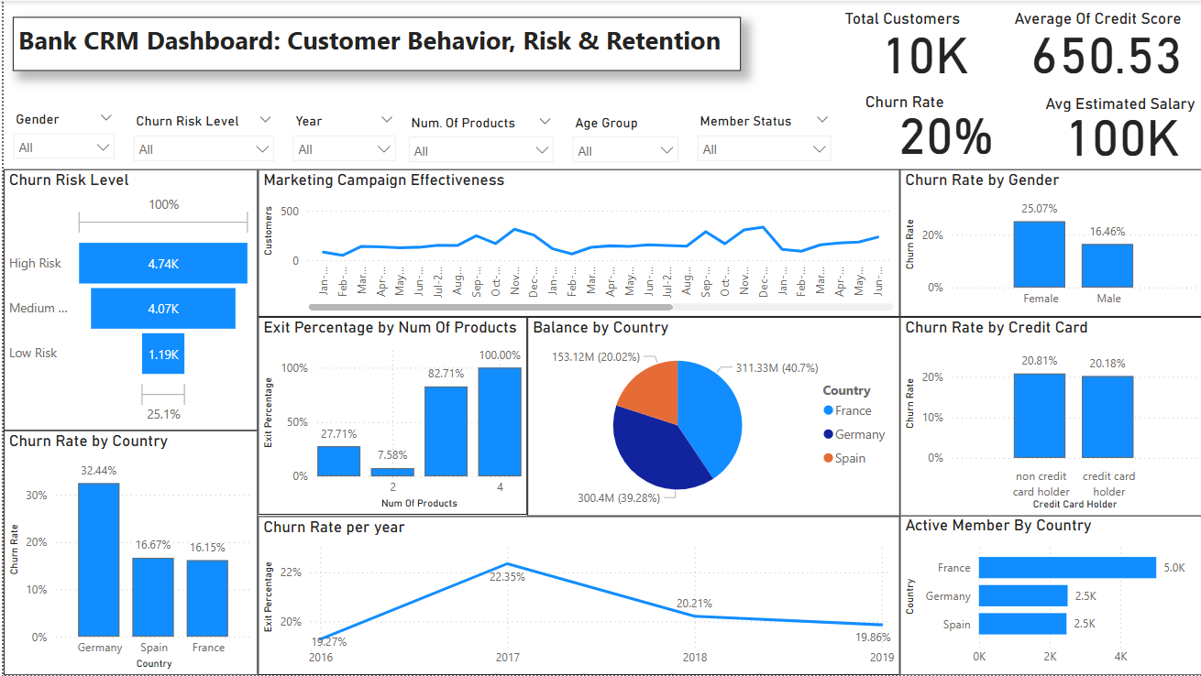
- How would you approach this problem, if the objective and subjective questions weren't given?
If the questions weren’t provided, I’d start by trying to understand the bank’s goals — like whether they’re facing issues with customer churn, low product engagement, or regional performance gaps. I’d spend time exploring the data to see what’s available — looking at things like customer profiles, product usage, activity status, credit scores, and churn history.
From there, I’d identify key metrics that matter to the business, such as churn rate, average balance, product adoption, and credit card usage. I’d also try to segment customers based on age, geography, tenure, or credit score to see if any trends emerge.
Once I start noticing patterns — like inactive members with only one product leaving more often — I’d dig deeper to validate those insights using SQL and Power BI. I’d then build visuals and dashboards that highlight the most important takeaways, such as which customer groups are at risk and where the bank should focus its retention efforts.
Finally, I’d summarize everything into a clear story with recommendations the business can act on — like re-engaging certain customer segments, promoting credit card usage, or improving product bundling.

- In the “Bank_Churn” table how can you modify the name of the “HasCrCard” column to “Has_creditcard”?
Using Power BI (Power Query Editor):
Go to Transform Data > Power Query Editor.
In the Bank_Churn table, find the column HasCrCard.
Right-click on the column name and select Rename.
Change it to Has_creditcard.
Click Close & Apply to save the changes.

Using SQL:

ALTER TABLE Bank_Churn RENAME COLUMN HasCrCard TO Has_creditcard;

